IDEATION PHASE
PROBLEM STATEMENT

Date | 23 JAN 2026
Team Id | LTVIP2026TMIDS81631
Project name | BOOK NEST: WHERE STORIES NESTLE
marks

Problem Statement: BookNest – Where Stories Nestle

In today’s digital age, readers face overwhelming choices, scattered book collections, and disconnected reading experiences across platforms.
Despite the vast number of books available online, discovering personalized content, organizing one's virtual library, setting reading goals.
engaging with a community of fellow readers remain fragmented and impersonal.






Book Nest aims to solve this by offering a centralized, warm, and intuitive digital space where stories truly "nestle"bringing together intelligent recommendations, virtual bookshelves, and communitydriven reviews in one seamless experience.

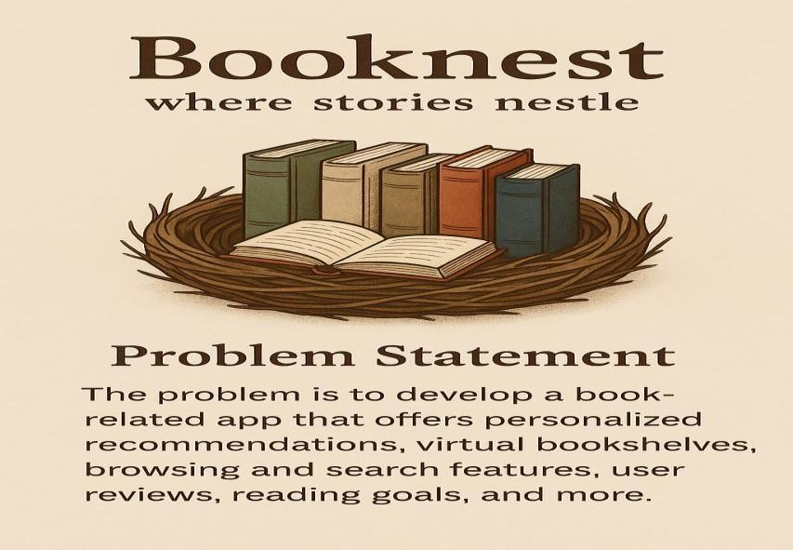

BookNest

is a modern, user
-
centric online bookstore designed to
make book discovery and purchasing seamless and enjoyable.
Whether you're a casual reader or an avid bibliophile, BookNest
offers a curated collection of genres, from timeless classics to
trending best
sellers.

With intuitive search, personalized recommendations, secure
checkout, and fast delivery, BookNest brings the charm of a
traditional bookstore into the digital age.

For authors and publishers, it also provides a powerful platform to
showcase an
d distribute their work. At its core, BookNest is more
than just a bookstore
—
it’s a vibrant community where stories find
their readers

